Project Name: Boost Converter Simulation

Name: Beitong Tian (bt346), Yixuan Jiang(yj373)

In the program assignment 5, we want to inherit the assignment 4 to make a boost converter simulation solver.

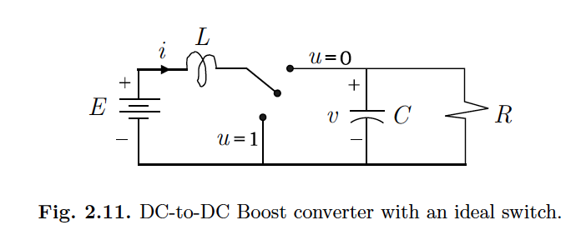

The boost converter circuit will contain an inductor and have two circuit states. We will use the parameters and the models according to the book written by Romeo Ortega.

We will modify the previous ODE solver to solve the equations below.

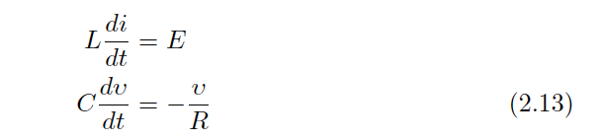

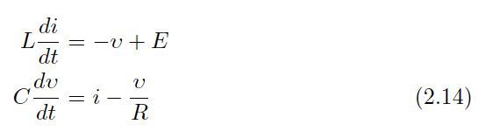

The difficulties for this solver is that the circuit will have two states. To solve this problem, for each state, we will use the results from the previous state as the initial values of the next state.

Our goal is to simulate the circuit and observe the output voltage stability. We will plot the output voltage for different parameter settings to observe the circuit performance.